CREATING AN UBUNTU SERVER
- Make sure that Virtualization is enabled; press ctrl+shift+esc to Open Task Manager, go to performance and check virtualization
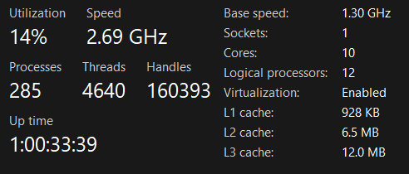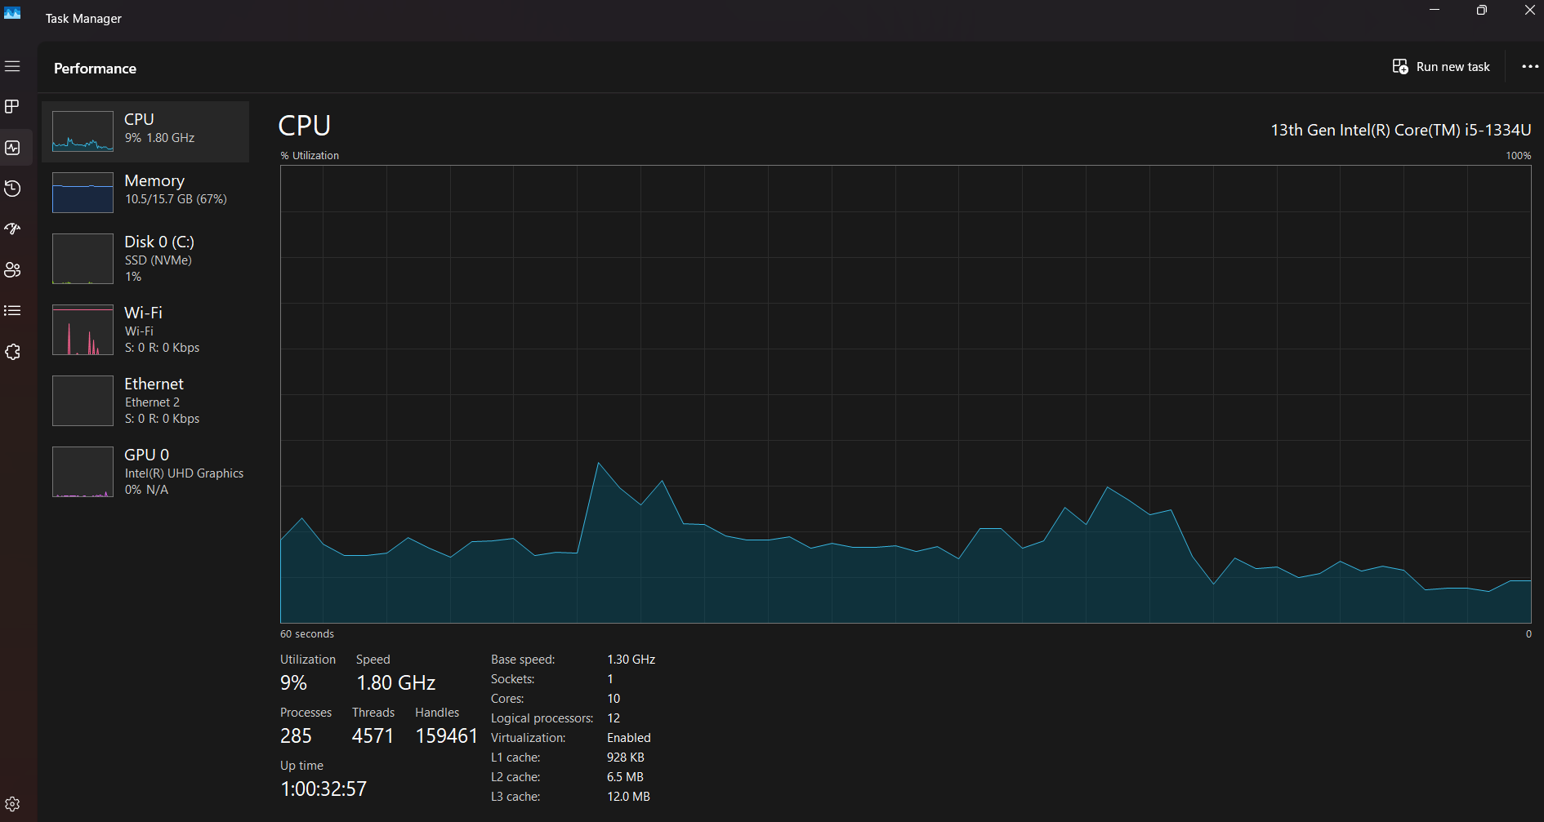

- Download Virtual Box from VirtualBox.Org. Check your OS version and Install.
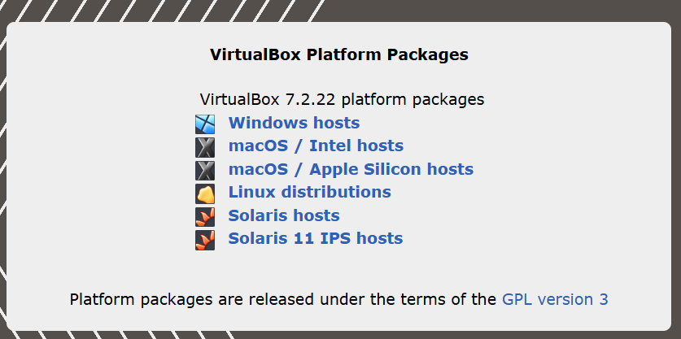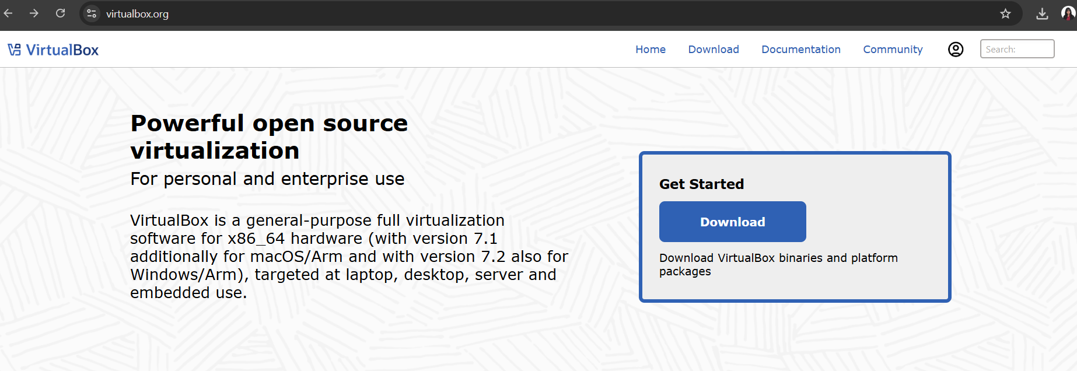

- Download Ubuntu ISO Server from
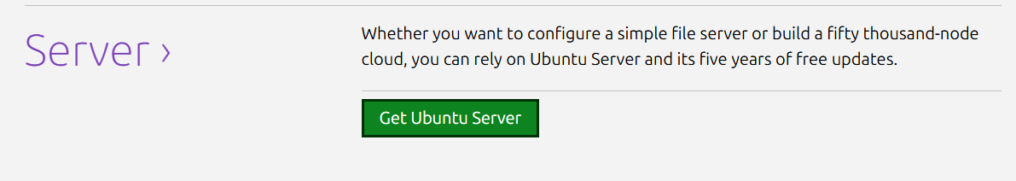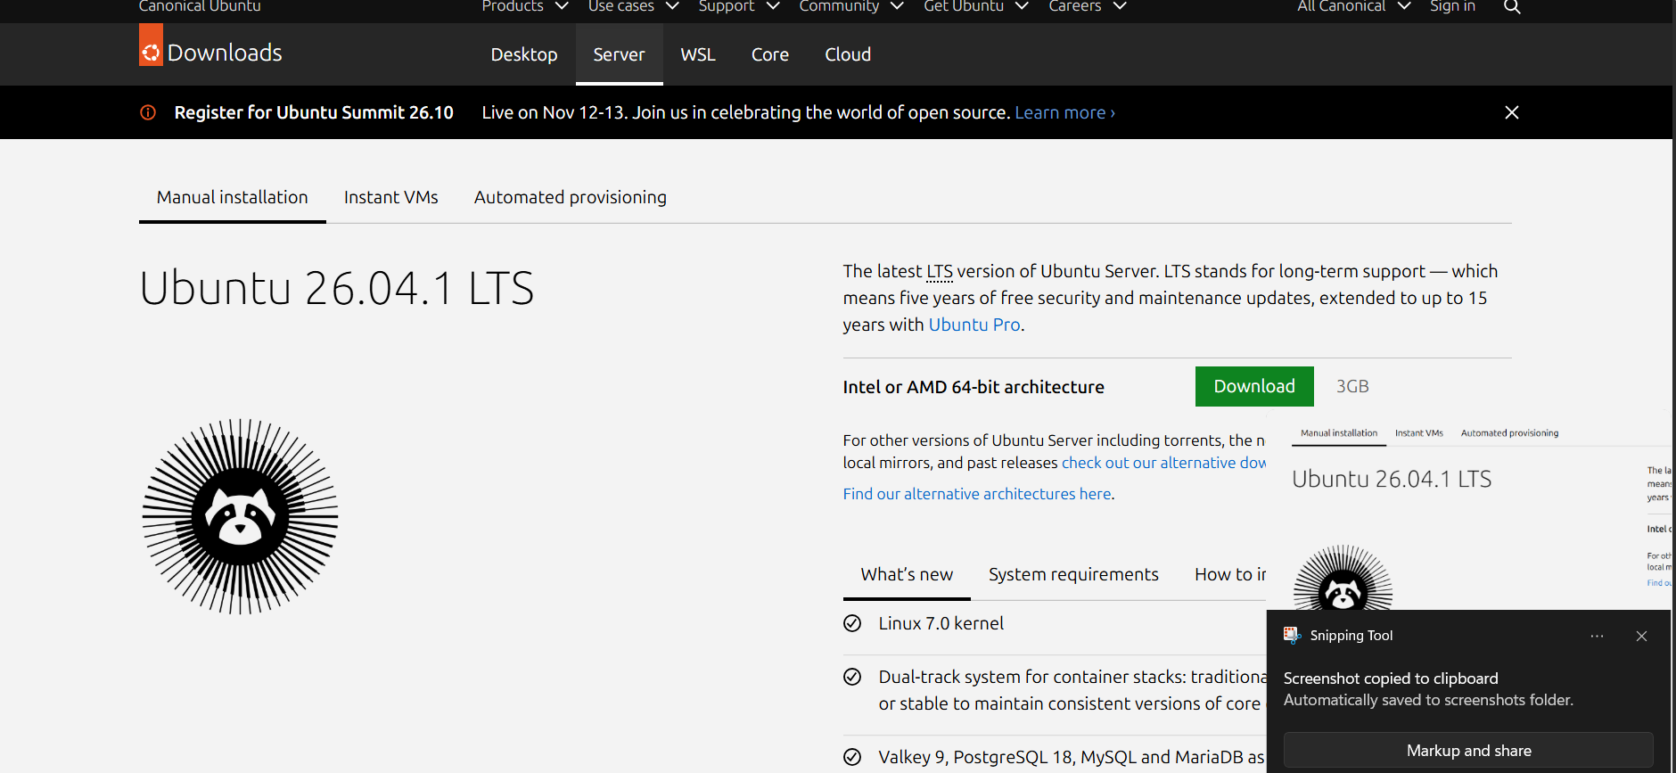
- 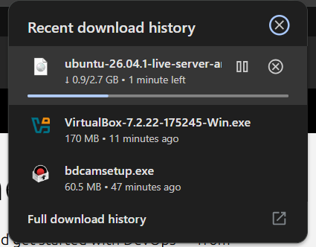
CREATING VM

REQUIREMENTS:
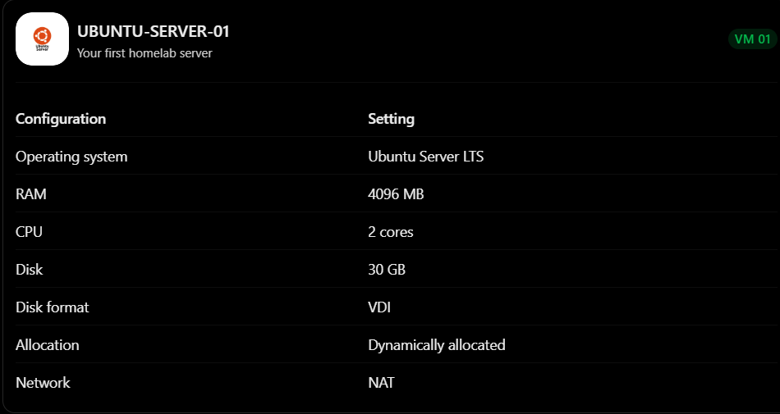
- Before creating the VM, let's organize where VirtualBox stores your virtual machines.
- Open VirtualBox.
- Click File.
- Select Preferences (or Settings, depending on version).
- Find Default Machine Folder under General.
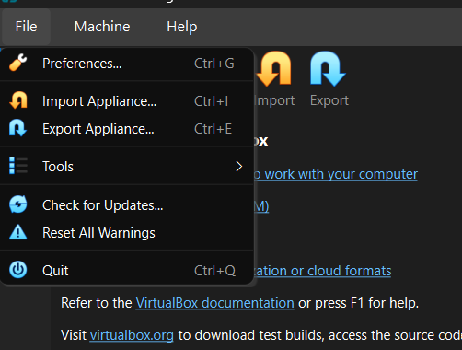
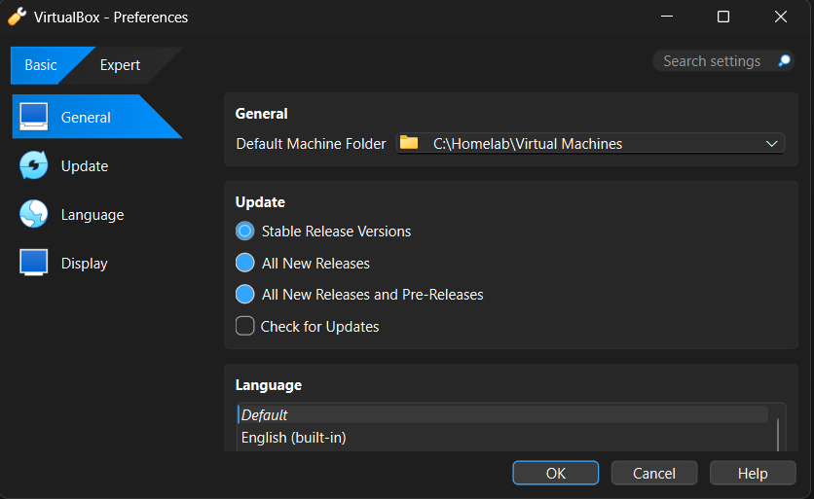
- Set it to preferred location

- Click NEW
Enter the following
Field | Value
Name | UBUNTU-SERVER-01
ISO Image | Select your Ubuntu Server ISO
Type | Linux
Version | Ubuntu (64-bit)
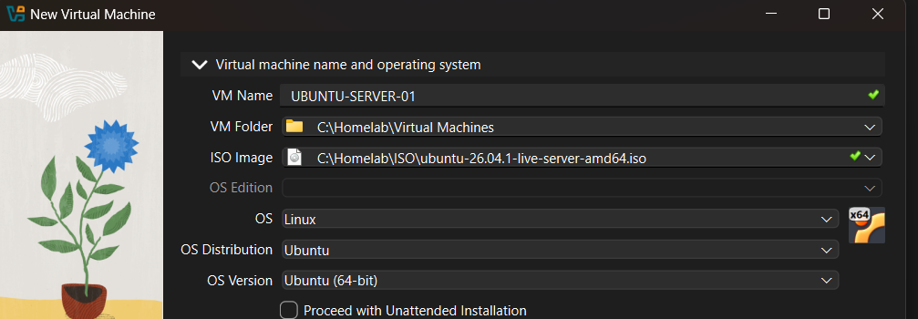
If you see an option called Unattended Installation, you can disable it for this first installation.
Why? We want to learn how to manually install Ubuntu instead of having VirtualBox automatically configure it.
Click Next.

Step 3. Configure RAM and CPU

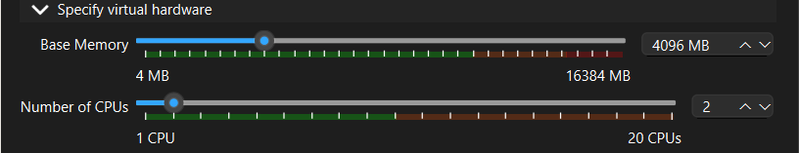

Step 4. Create a virtual hard disk
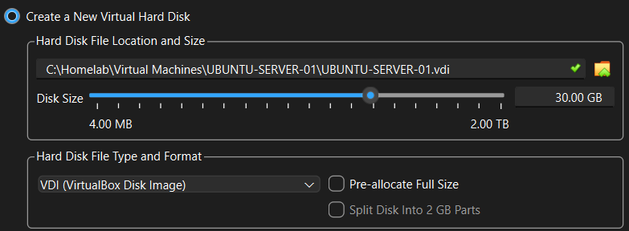
- Create a Virtual Hard Disk Now.
- Disk file type: VDI.
- Storage: Dynamically Allocated. (If not in option, leave unchecked)
Step 5. Make Sure that Adapter is NAT

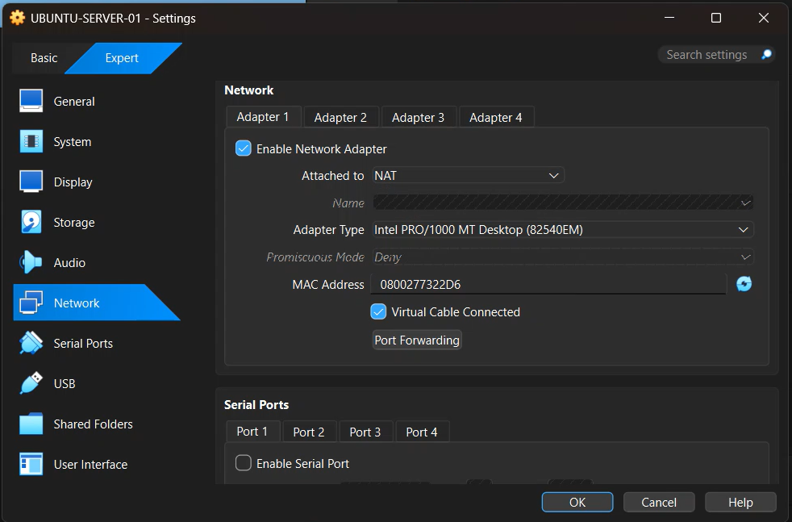

SET UP VM
Run the VM and do the following
STEP 1: Wait for countdown to finish
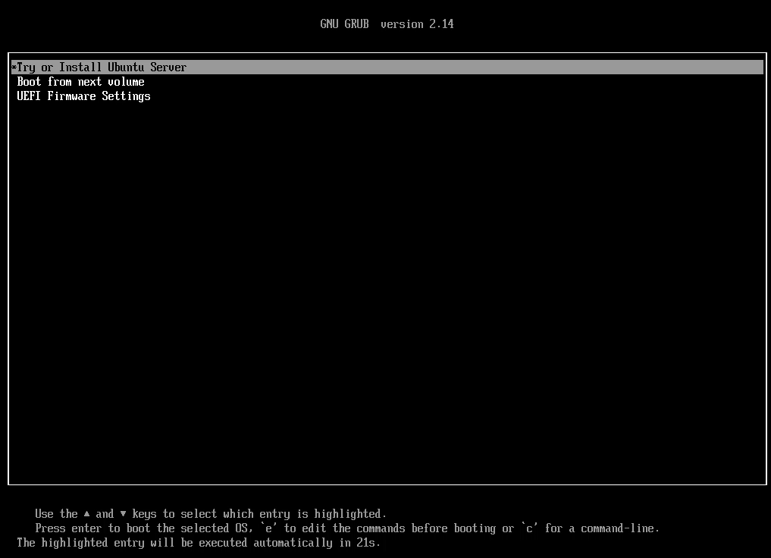
Step 2. After countdown, installation will begin wait for it to finish
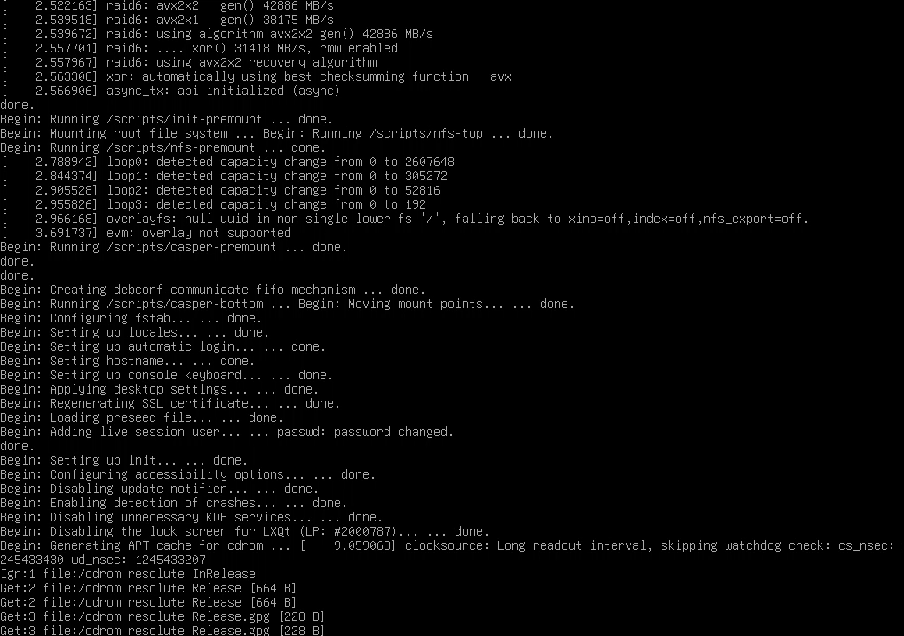
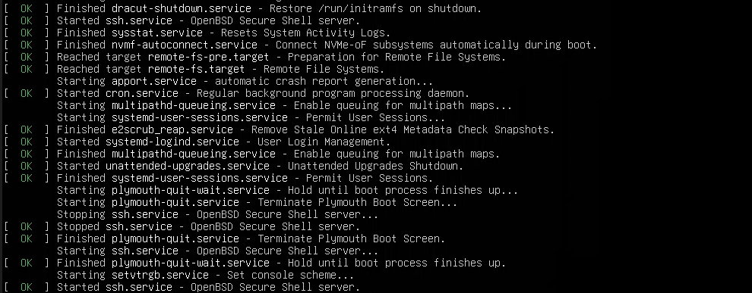
Step 3. Select Language, English Preferrably
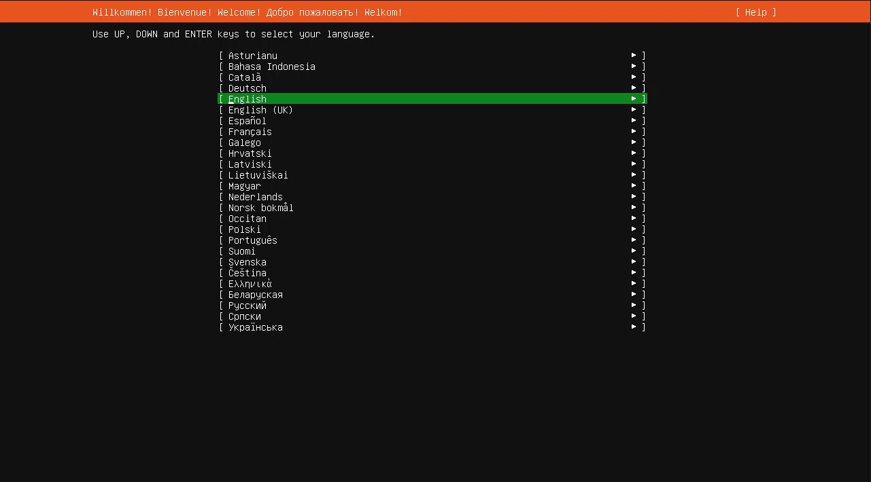
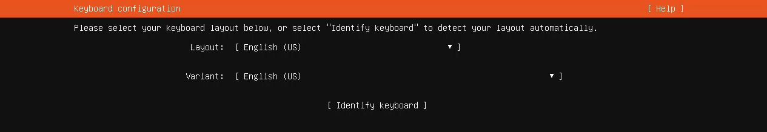
Wait for this to load for a while (like 3 mins) then click done
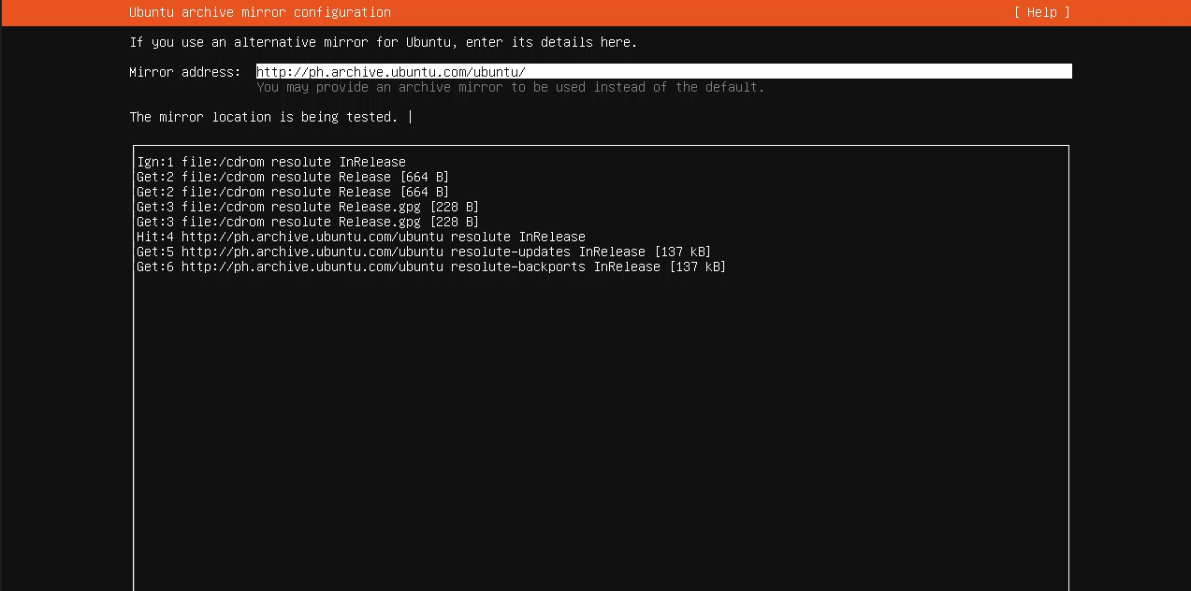

Step 4. Select ‘Use an Entire Disk’ and ‘Set up this disk as an LVM group’. If you see OpenSSH Server, check that option

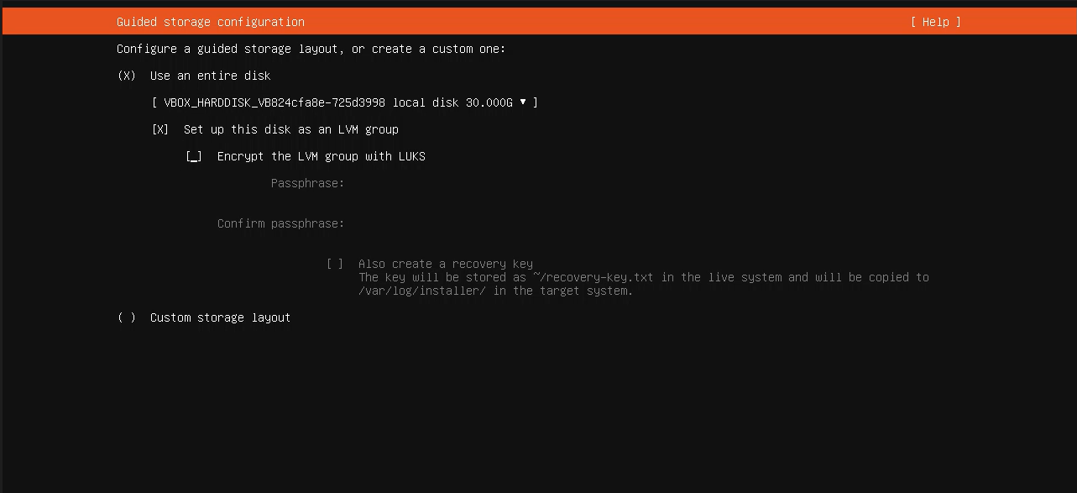

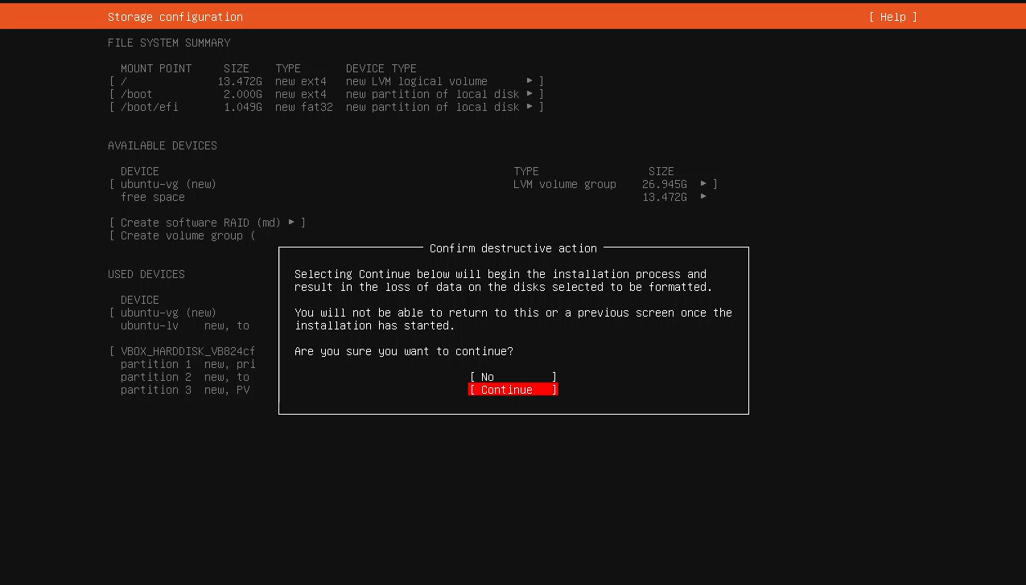

Step 5. Fill out this form, make sure your servers name is ‘UBUNTU-SEVER-01’

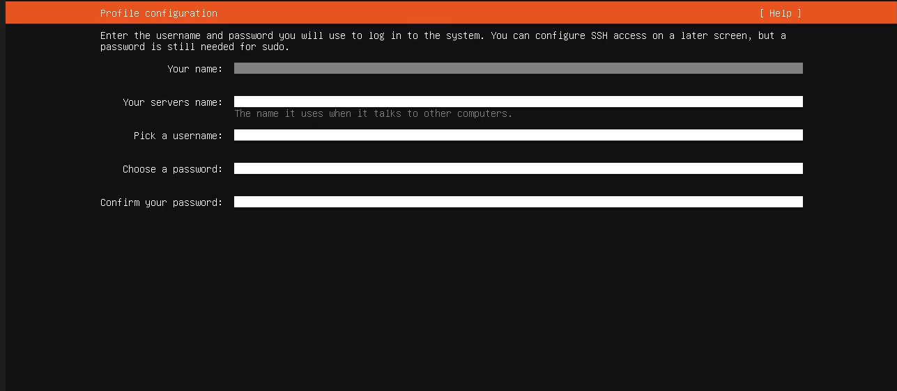
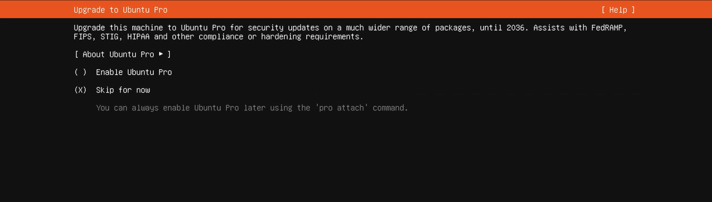
Select Install OpenSSH server
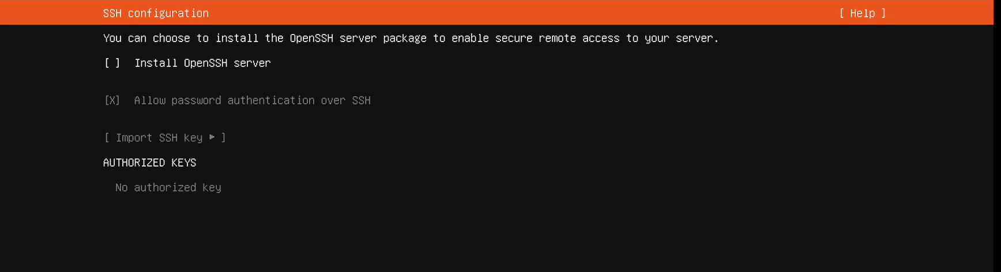

You will see this screen again after that
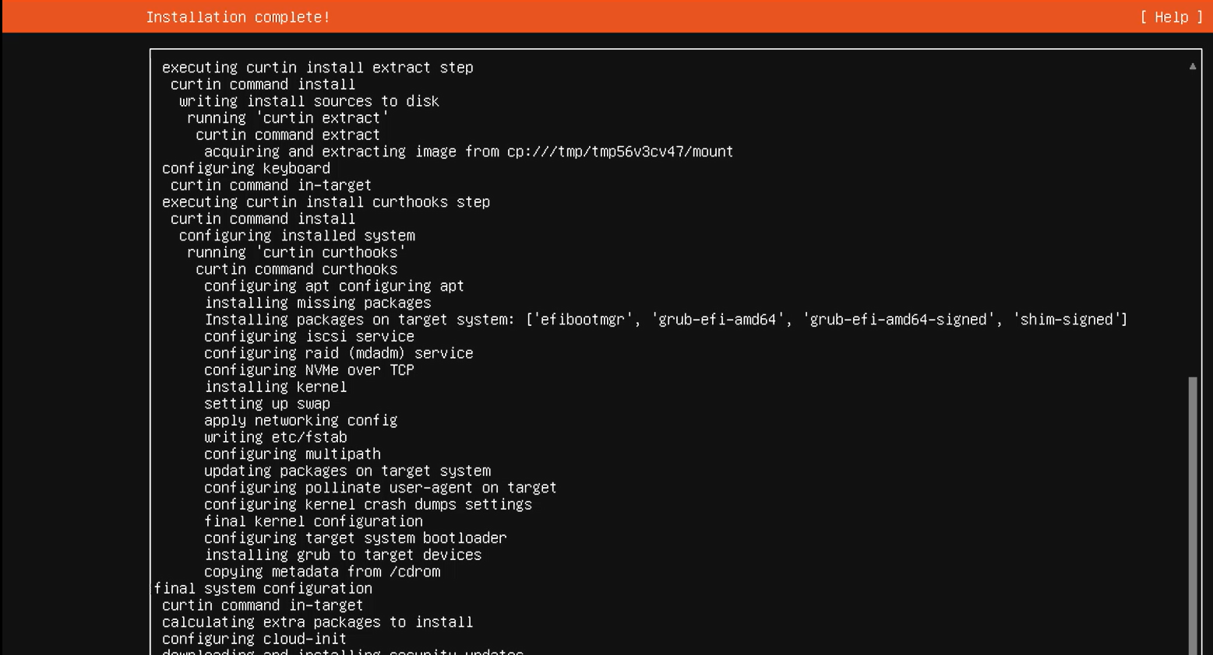
If you see this eject the ISO file.
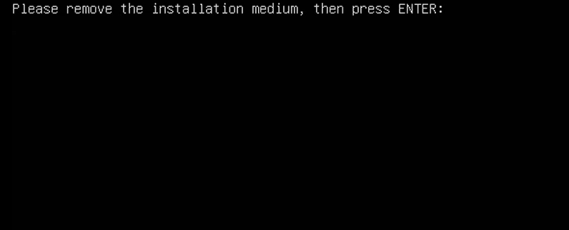
Shut down VM first, open VM manager, select UBUNTU-SERVER-01, Click Settings, Select Storage, Under IDE controller, select the UBUNTU ISO, click the small CD icon and remove. If you don’t see ISO there, it auto ejected and that’s okay.
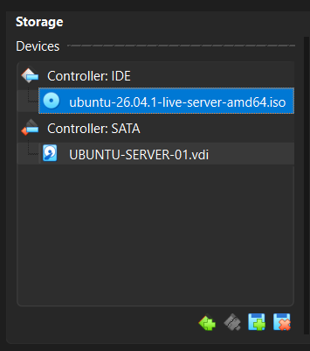

Step 6: Run machine again and it shall bring you to log-in screen, enter credentials. And success screen shows this:
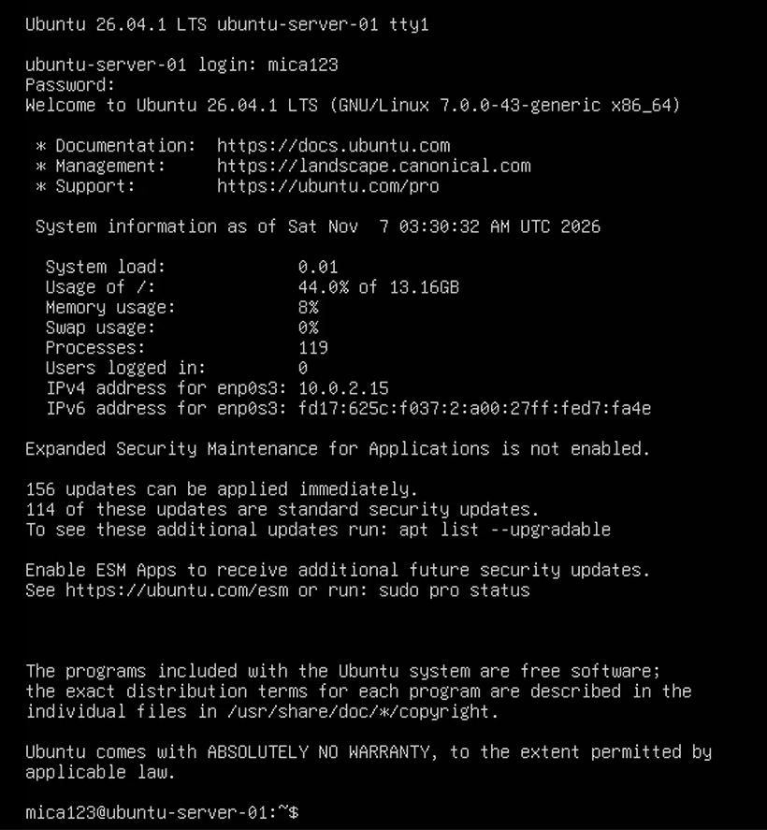

Step 7. enter sudo apt update command and enter your password to update packages
Step 8. Enter sudo apt upgrade and enter password to upgrade
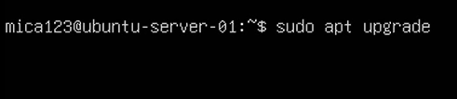
Step 9. Type ‘Y’ and just wait for it to finish

Step 10. Type lsb_release -a to check your linux version
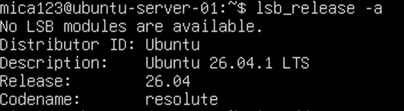
Step 11: type ip addr to check internet connection, look for ‘enp0s3’, and ip address, something like ‘10.0.2.15’.
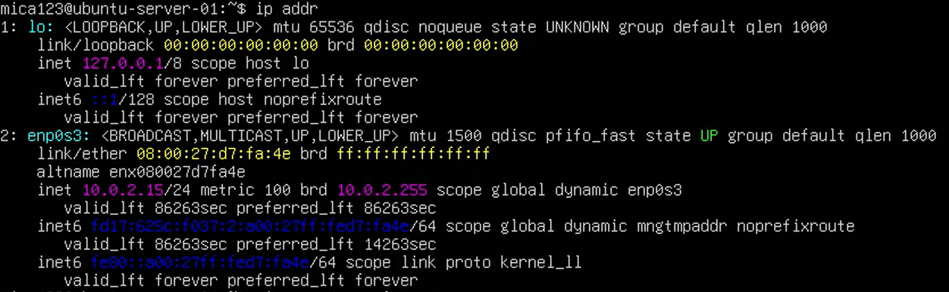
Step 12. Type ping -c 4 google.com to check if internet works, replies should look like this if it’s successful.


